XANGOSTEEN – BAX

Multi-Client Singapore

XANGOSTEEN
System Narrative
Ver 1.0

Review and Sign off

The following parties have confirmed and reviewed the specifications presented in this document against selected business processes.

Contents are subjected to change pending further review and revision of this document

Revision History 3
System Requirements 4
1. Storer Key 4
2. Downloading of Orders 4
3. Uploading of Shipment Tracking Nos. 4
4. Returned Goods 6
5. Maintenance of Order Information 7
6. Multiple Orders in a Wave 8
References 10
1. Xangosteen Business Narrative 10
2. Xangosteen Uploading and Downloading Program User Guiide Ver 1.0.doc 10

Revision History

Revision List
Author | Date | Version | Description
Hazel Han | 20 Dec 06 | 1.0 | Initial Version

System Requirements
This document specifies requirements that are already developed as at the date of this document.
It does not cover all requirements as documented in the Xangosteen Business Narrative

Storer Key
The storerkey of the program is ‘XANGO’. As such, system logic specific for Xangosteen will identify data through this storer key.

Downloading of Orders
Orders have to be downloaded from GTI system and imported into the database.
Below are the mappings:

Orders Header File - > Orders
File Type: ASCII, separated by tabs
Name of the file: H_ddmmyy.txt. “H” is for Header, ddmmyy is the date the file was created (dd = day, mm = month, yy = year)

Filed Number | Field Name | Data Represented | Bax Field
1 | Customer Delivery # | XanGo Distributor ID | B_company
2 | Customer Order # | XanGo Order ID | Externorderkey
3 | Ship to Address 1 | Shipping Line1 (max 45 characters) | S_address1
4 | Ship to Address 2 | Shipping Line2 (max 45 characters) | S_address2
5 | Ship to City | Shipping City | S_address1_a
6 | Ship to country | ‘Singapore’ | S_Country
7 | Ship to Postal Code | Shipping Postal Code | S_zip
8 | Ship to contact person | Shipping to | S_company1
9 | Contact Person tel. no | Tel. No | S_phone1

Order Lines File -> OrderDetail
File Type: ASCII, separated by tabs
Name of the file: H_ddmmyy.txt. “H” is for Header, ddmmyy is the date the file was created (dd = day, mm = month, yy = year)
Filed Number | Field Name | Data Represented | Bax Field
1 | Customer Order # | XanGo Order ID | ExternOrderkey
2 | Line # | Consecutive number | Externlineno
3 | Product # | Product SKU | SKU
4 | Product Description | Product Name | N.A
5 | Qty Order | Quantity being shipped | OpenQty

Uploading of Shipment Tracking Nos.
Orders shipped wave have to have their tracking nos. uploaded into GTI system.
Below are the mappings:

Orders Shipped -> Tracking File
File Type: ASCII, separated by tabs
Name of the file: T_ddmmyyyy99999.txt. “T” is for Tracking, ddmmyyyy is the date the file was created (dd = day, mm = month, yyyy = year) . 99999 is the running no. of the genrerated file.

Filed Number | Field Name | Data Represented | Bax Field
1 | Customer Order # | XanGo Order ID | Orders.ExternOrderKey
2 | Tracking # | Tracking # | Wave.Descr

For details on how to do the downloading and uploading, please refer to Xangosteen Uploading and Downloading Program User Guiide Ver 1.0.doc

Tracking # will be updated in the Wave Description field through Exceed’s Task Manager - > Planning -> Wave module.
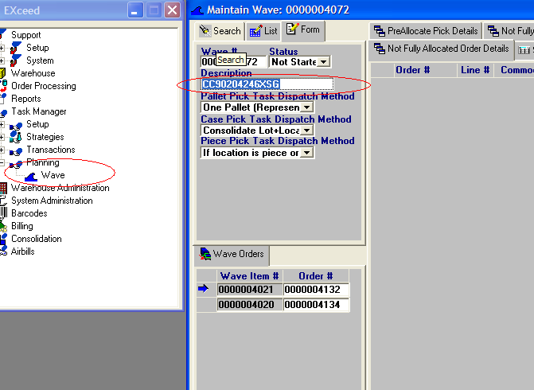

Returned Goods
Goods returned will generate a new batch no ( Lottable02) for a ‘receipt line type ‘ of ‘Returns’.
Format of the batch no. will be : SNGYYDDD where ‘SNG’ indicates Singapore, YY : a 2-digit current year, DDD: Julian Date of the current date.
Do note that users have to indicate the original batch no. in the ‘Batch No.’ field to allow traceability.
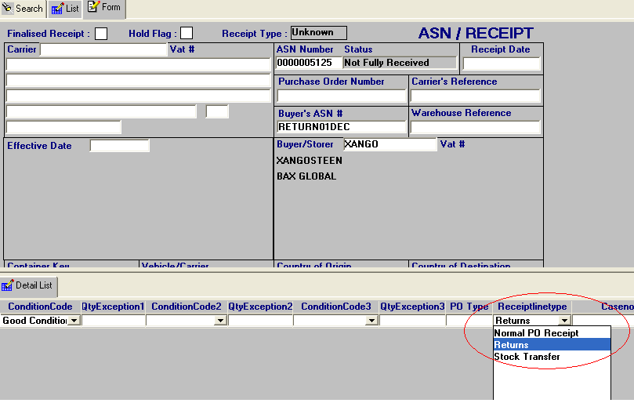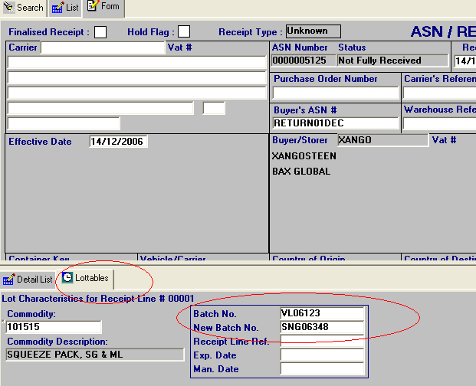

Maintenance of Order Information
Downloaded Order Information such as the contacts, address, etc can be amended in the Hub in the Outgoing -> Shipment Order Screen.
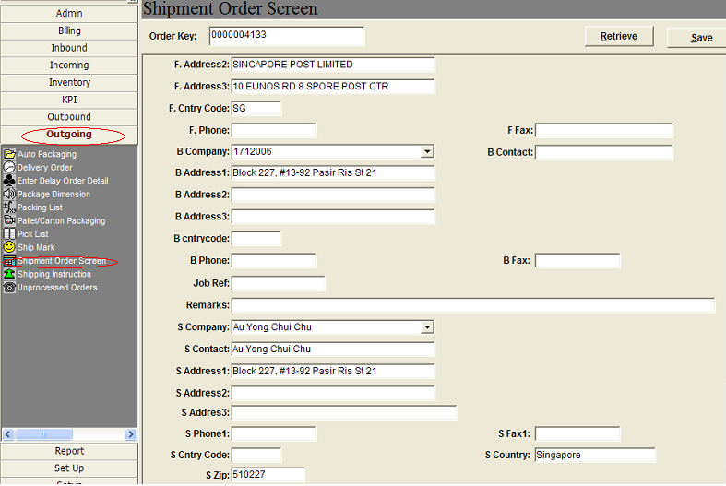

Multiple Orders in a Wave
There can be multiple orders in a wave. As such, format of documents such as Pick List, Delivery Order and Packing List will display multiple order information for a wave. (This is unlike the other programs in the NTC hub )

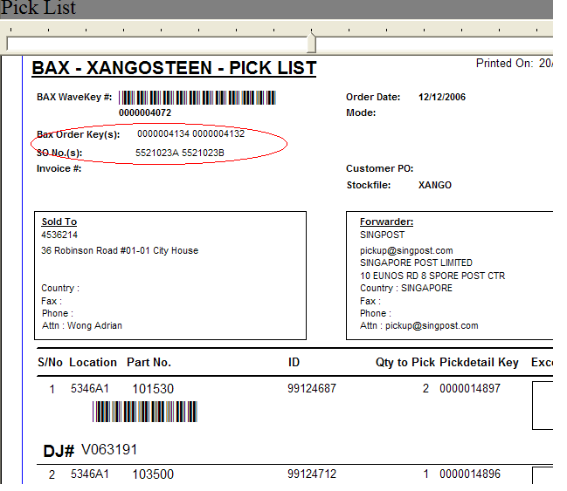

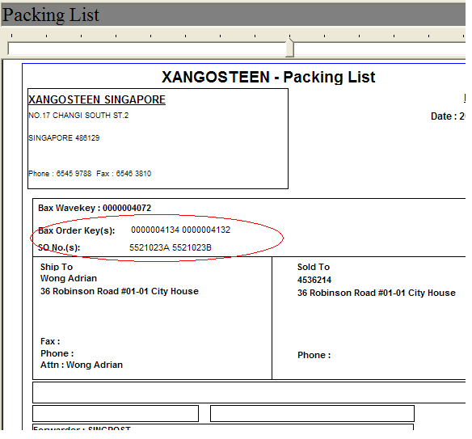

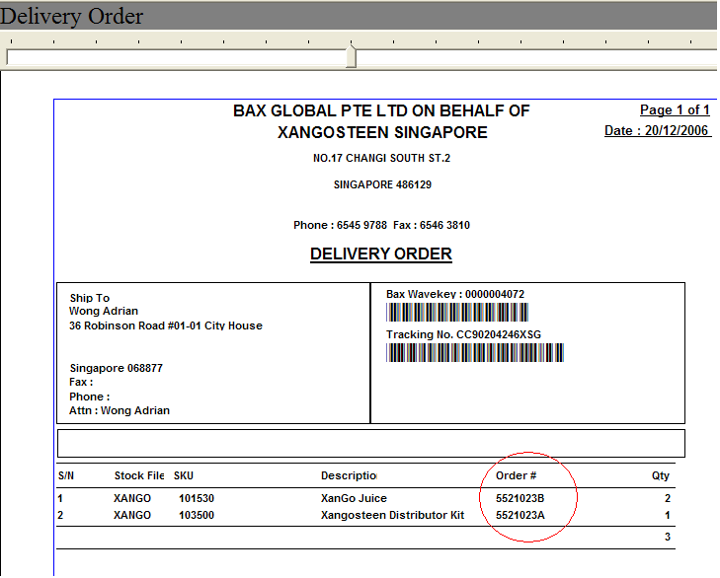

References

Xangosteen Business Narrative
It contains the business process and requirements.

Xangosteen Uploading and Downloading Program User Guiide Ver 1.0.doc
It contains the user guide for uploading and downloading of shipments and tracking nos.

